NAS Alarm Clock

Content

Download and installation instructions 2

Step 1 2

Step 2 2

Step 3 2

Initial package settings 3

Set up internal account 3

Set up license 3

Minimal permissions for Alarm Clock account 4

Adding new musical alarm 5

Main window actions 5

Task settings 6

# Download and installation instructions

see <http://www.nasalarmclock.com/downloads/qnap/>

## Step 1

Download the package:  
<http://www.nasalarmclock.com/qnap-packages/AlarmClock_1.01.qpkg>

Click “Save link as…” and save the package to your local disc.

## Step 2

Log into your QNAP NAS as administrator.

Open **App Center**.

Press **Manual install** button on the toolbar.

Press **“Browse…”** button.

Select package file from your local disk.

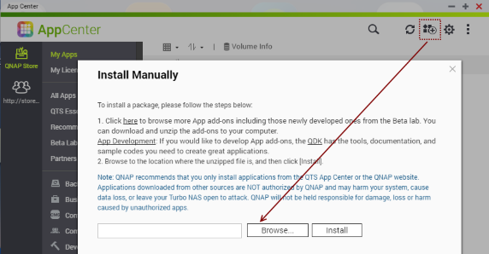

Press **“Install”** button.

## Step 3

Check that new package **“Alarm Clock”** is appeared in the AppCenter.

# Initial package settings

see <http://www.nasalarmclock.com/qnap/description/mainsettings/>

## Set up internal account

**QNAP AlarmClock** uses standard QNAP Music Station web API for playing the music.

You should set up the internal account that will be used to call this web API.

Click on **“Settings”** button on the toolbar.

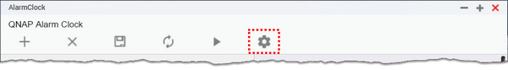

A window for entering a name and password for the account will be opened.

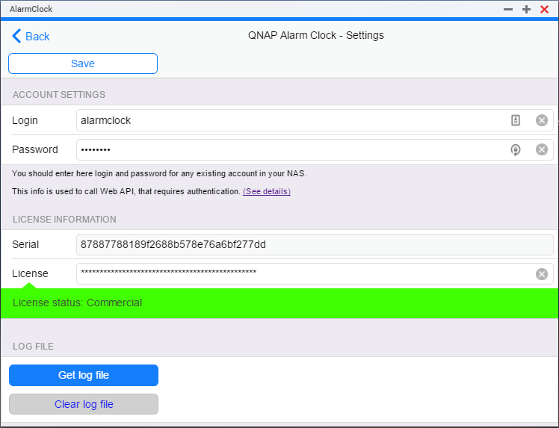

* Enter here login and password of any account you want to use for AlarmClock package.
* We suggest creating the special account for AlarmClock package with limited permissions (see below).

## Set up license

In the same window, you should enter the license for your package.

License may be either 30-days trial or commercial.

* Without any license, the playback time will be only 10 seconds.
* To obtain 30-days evaluation license, go to [“My Account”](http://www.nasalarmclock.com/my-account/) page, Select “My Licenses” tab, and generate new trial license for your NAS.
* NAS Serial code you should copy from settings window and use for license generation.
* If you like the package, you may [buy the commercial license](http://www.nasalarmclock.com/purchase/).

## Minimal permissions for Alarm Clock account

For use in QNAP Alarm Clock, you may set up the minimal permissions for Alarm Clock account, that allows calling Music Station web API and nothing more.

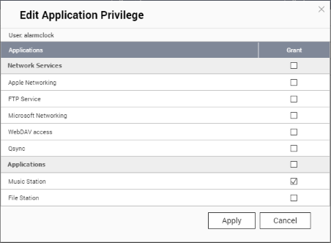

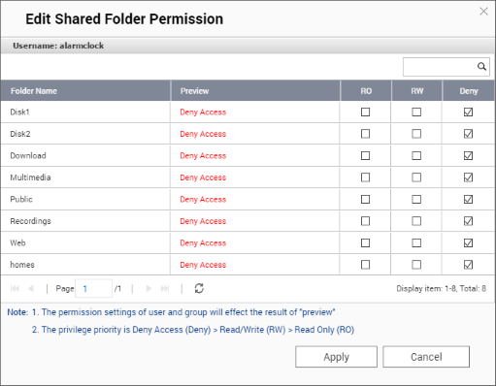

# Adding new musical alarm

see <http://www.nasalarmclock.com/qnap/description/addnewalarm/>

## Main window actions

The main window consists of a toolbar **(1)**, the list of tasks **(2)** and the settings panel for the selected task **(3)**.

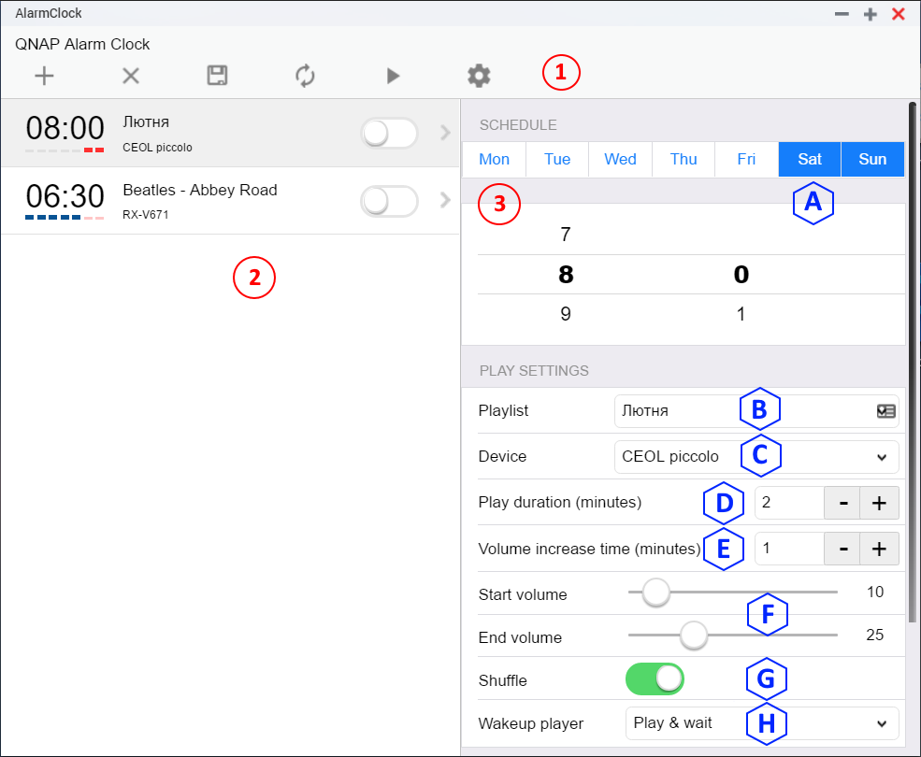

* Click **“+” (Add)** button to add a new task (alarm). The new task will be added to the task list.
* Select the new task in the list.
* In the task settings panel, you can adjust the settings of the selected task. (See the task settings below)
* All the settings you have made for the task appear in the task list. But there will not be saved in the settings DiskStation.
* Tasks with unsaved changes are marked with blue bar on the left.
* To save all of your settings, click **“(disc)” (Save)** button on the toolbar. All the settings will be saved to NAS and added to NAS scheduler.
* **“x” (Delete)** button deletes the selected task from the task list.
* **“(arrows)” (Reset)** button returns the task list to the last saved state if you inadvertently delete any task or chose wrong settings.
* The **“(triangle)”** **(Start)** button launches the selected alarm just now, so you can check the task settings without waiting for the scheduled time. If the test playback fails, you will see the window with information about the error.

## Task settings

When the task is selected in task list, you could set custom settings for this task:

* **(А) Schedule.**
  + Select the days of the week, when alarm should play.
  + Set the time.
* **(B) Playlist.** You see a list of playlists that are configured in **Music Station**. You can create (in **Music Station**) special playlist for your alarm clock.
* **(C) Player.** Select the device to play from the list of devices available in the Music Station.
  + This can be a USB sound card or USB speakers or a network player supporting **DLNA** protocol.
  + AlarmClock can play on all local and network players that are available in Music Station.
* **(D) Play duration** (in minutes). After a specified time, the playback will stop (and you can continue to sleep)
* **(E) Volume increase time** (in minutes).
  + Adjust the fade.
  + Specify the starting and ending volume, and the time during which the volume will increase.
  + If the specified time is less than the total duration of the sound, playback will continue with the final volume all the time remaining.
* **(F) Start & End Volume.**  In percent – from 0% (silence) to 100% (very loud)
* **(G) Shuffle.** If you have a lot of music in your playlist, you may prefer to listen them in random order each morning.
  + Turn the shulle on, if you want to listen music in random order.
  + Turn it off, if you wish to listen music in the same order as was set in playlist.
* **(H) Player wakeup.** (does matter for network players)
  + Not only you, also the player should wakeup before it can play the music. The majority of network players are automatically turn on (go from sleep mode) and begin playback, when the music starts. However, some players are not.
  + There is some settings for different players, how better to wake them.
  + For **yamaha** network players or AV receivers, there is special command that should be sent to wakeup it.
  + Some other players / receivers (Denon for example) turn on automatically when the music begins, but this wakening take 10-30 seconds. There is special setting **(play & wait)** for such players.
  + For all the other players simply select the option **“No”** – do nothing special.